School of Informatics & IT
Diploma in Applied Artificial Intelligence
Machine Learning for Developers (CAI2C08)
AY2026/2027 April Semester
Program Codes
SUBMITTED BY:
(Name of student) | (Admin number)
Toh Jun Yu | (2500501H)

Declaration of Originality
I am the originator of this work, and I have appropriately acknowledged all other original sources used as my reference for this work.
I understand that Plagiarism is the act of taking and using the whole or any part of another person’s work, including work generated by AI, and presenting it as my own.
I understand that Plagiarism is an academic offence
and if I am found to have committed or abetted the offence of plagiarism in relation to this submitted work, disciplinary action will be enforced.
(Name of student) | (Signature)
Toh Jun Yu | Toh Jun Yu

AY2026-27 APRIL SEMESTER
Declaration on the use of Generative AI tools for assignments
Include the links of your Generative AI conversations below:
Describe how you have used Generative AI tools such as ChatGPT or Dall.E-2 in your assignment.
Show snapshots of the conversations with the AI tool (i.e., the prompts you used and the response you get from the AI tool).
https://chatgpt.com/share/6a6bc1a9-bed4-83ec-a8c4-3ac8a1c35ea0
audit my code here in my progam code compare specs tell me anything i need to tweak

Audit complete. It's deadline day (5pm today) — here's exactly where you stand.
Notebook vs spec — passes everything except one line
Spec requirement | Status
sklearn only, 4 models, logs/outputs shown | ✓
RandomizedSearchCV only, ≤3 values per hyperparameter | ✓ both rounds
Metric justified incl. why not MSE/RMSE | ✓
Assumptions stated (3.3) | ✓
Feature eng/selection with CV evidence | ✓ 6.1–6.3
Tuning summary + reproducible setup | ✓ 6.5
Clean top-to-bottom run, no errors | ✓ 22 cells, sequential
Name + ID filled | ✓
Skew/IQR claims evidenced | ✓ — output now shows skew = 0.59, 441 rows (0.9%) matching your markdown exactly
✗ Gen AI citation — the single unmet spec bullet. "Cite any use of Gen AI tools in your Declaration of Originality; doing so will not affect your marks." One sentence in the declaration cell: "I used Gen AI tools (Claude) to assist with code review, debugging and documentation; all code and results were verified by me." Two minutes, and it's plagiarism-policy insurance on a 50% component. Do this first.
The thing that will actually bite: app.py is not pushed
git diff shows 34 insertions / 69 deletions sitting uncommitted — the light-mode pinning, table fixes, Reset button, LaTeX fix, comment cleanup. The deployed app still has yesterday's bugs. If you screenshot the deployed link now, you screenshot the black tables. So:
git add -A
git commit -m "Pin light theme, fix tables and reset button, clean comments"
git push
Then open the live URL, confirm it matches local, and only then take the three screenshots (fresh load → prediction → changed prediction; not Punggol EXECUTIVE).
Minor / optional
- Exec counts read 19–40 with the histogram cell at 41 (you re-ran it after adding the evidence lines). Order is still provably clean; a final Restart & Run All is polish only — skip it if time is tight, it's ~35 min you may not have today.
- README is one plain line now. Fine. Adding the live app URL would help the marker, 30 seconds.
The remaining deliverable
Word doc on the LMS template: declaration, dataset source (data.gov.sg link), GitHub link, Streamlit link, 3 screenshots, git-history screenshot → zip as Toh Jun Yu_2500501H.zip (no RAR, exclude nothing you need — ipynb + app.py + docx minimum) → upload well before 5pm. Late = −10 marks per day, and everything graded is already done.

An AI-assisted code review was conducted to verify that the notebook met the assignment requirements. The review identified that the implementation satisfied the specified modelling and evaluation criteria and highlighted a missing GenAI declaration as well as the need to ensure the latest version of the Streamlit application was committed and pushed before submission (Anthropic's Claude AI language model, personal communication, July 31, 2026).
How to indicate the reference?
The content generated by AI tools is not retrievable except by the user who generated them, so they are considered non-recoverable sources. For non-recoverable sources:
- do not include in a reference list
- cite within the text as personal communications or correspondence
Based on APA 7th edition referencing format,
(Communicator, personal communication, Month Day, year)
E.g. (Paraphrase from OpenAI's ChatGPT AI language model, personal communication, March 8, 2023).

Important Note:
- Do not copy answers produced by the AI tool in totality as it is considered as plagiarism.
- Do not rely on any information produced by the AI tool blindly. You should always verify the answer with other sources. Do not assume that these answers provided by the AI tool are correct.
- To achieve quality outputs from the AI tool, you should provide good prompt that is clear and specific. Be precise and provide context. Avoid asking open-ended questions.

References / Citations

Source of dataset | https://data.gov.sg/datasets?query=hdb+resale&resultId=d_8b84c4ee58e3cfc0ece0d773c8ca6abc
GitHub link | https://github.com/niroxzv/mldpschooljunyu.git
Streamlit link | mldpschooljunyu-awrb3twabatv3rynxxwey9.streamlit.app

3 screenshots
(1) Before any option is selected
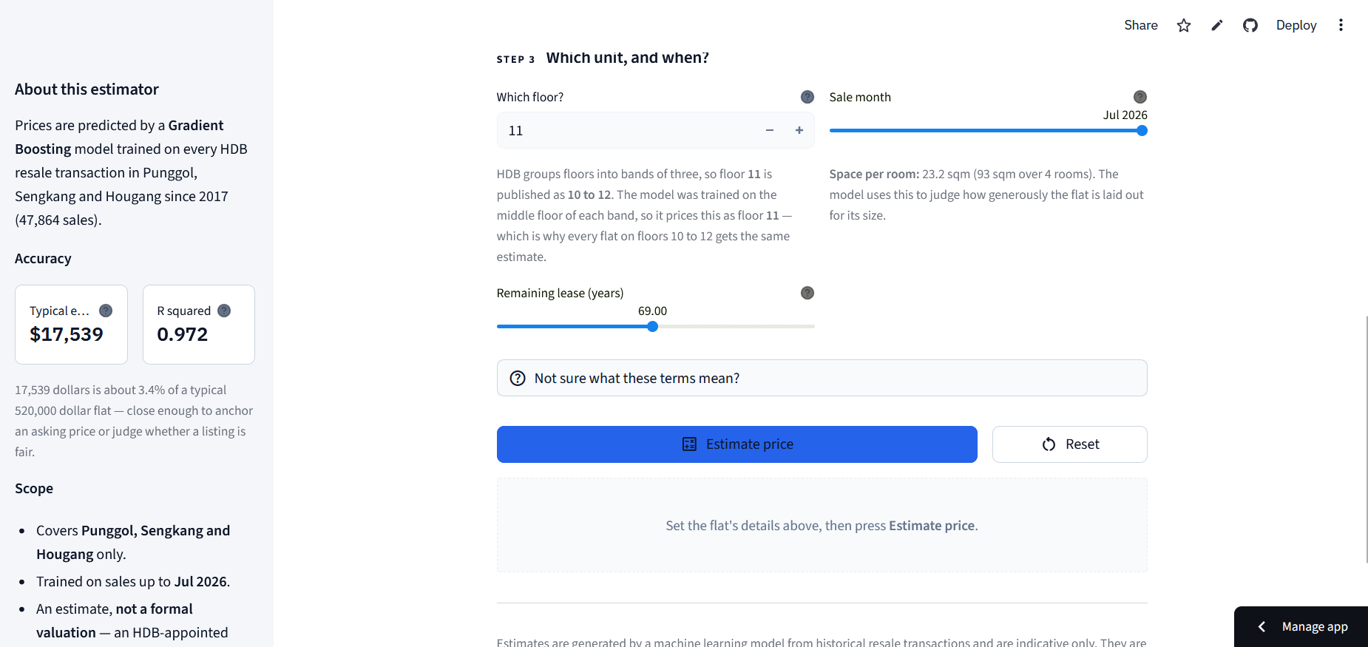
(2) After an option is selected (should show a prediction)

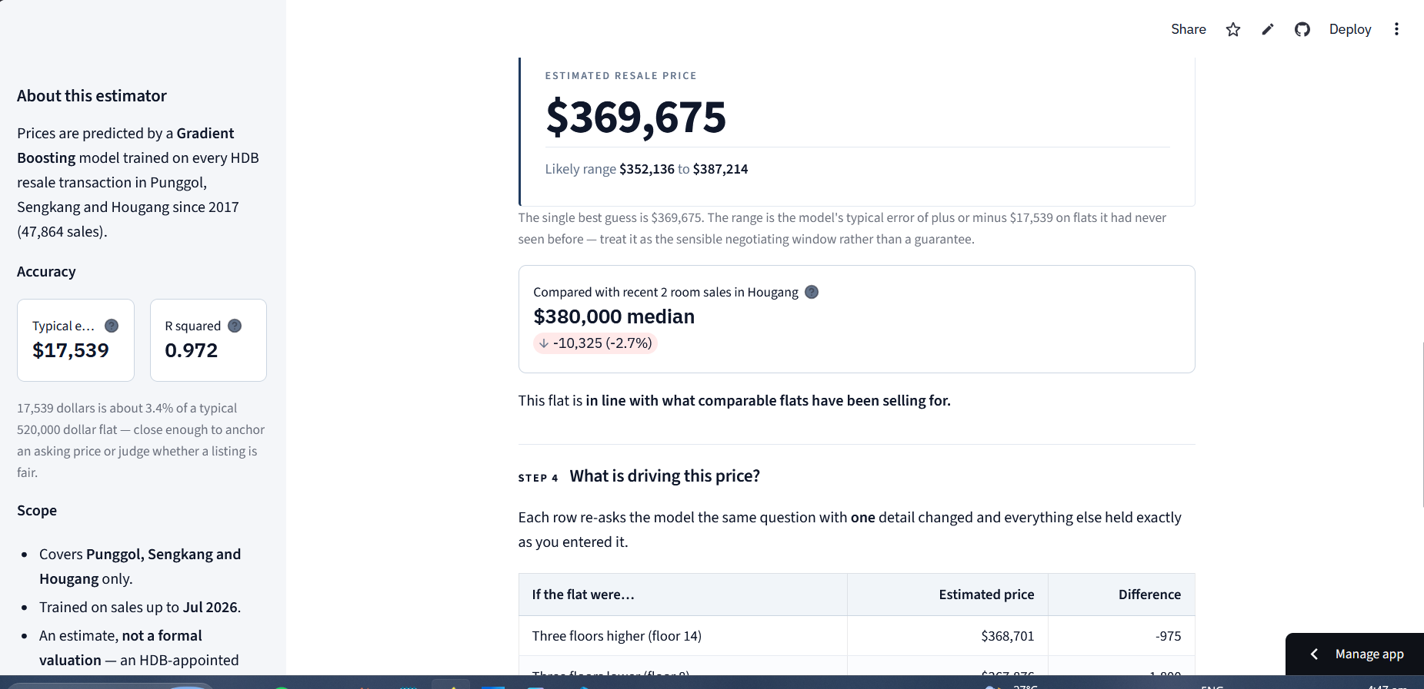
(3) After another option is selected (should show a change in value for the
prediction)
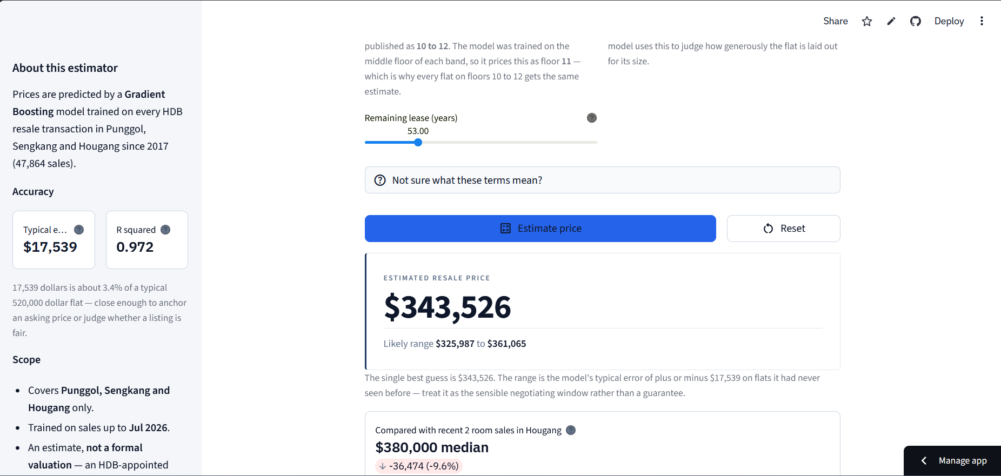

Screenshots of version control or development logs (if applicable)
